Compass Rose
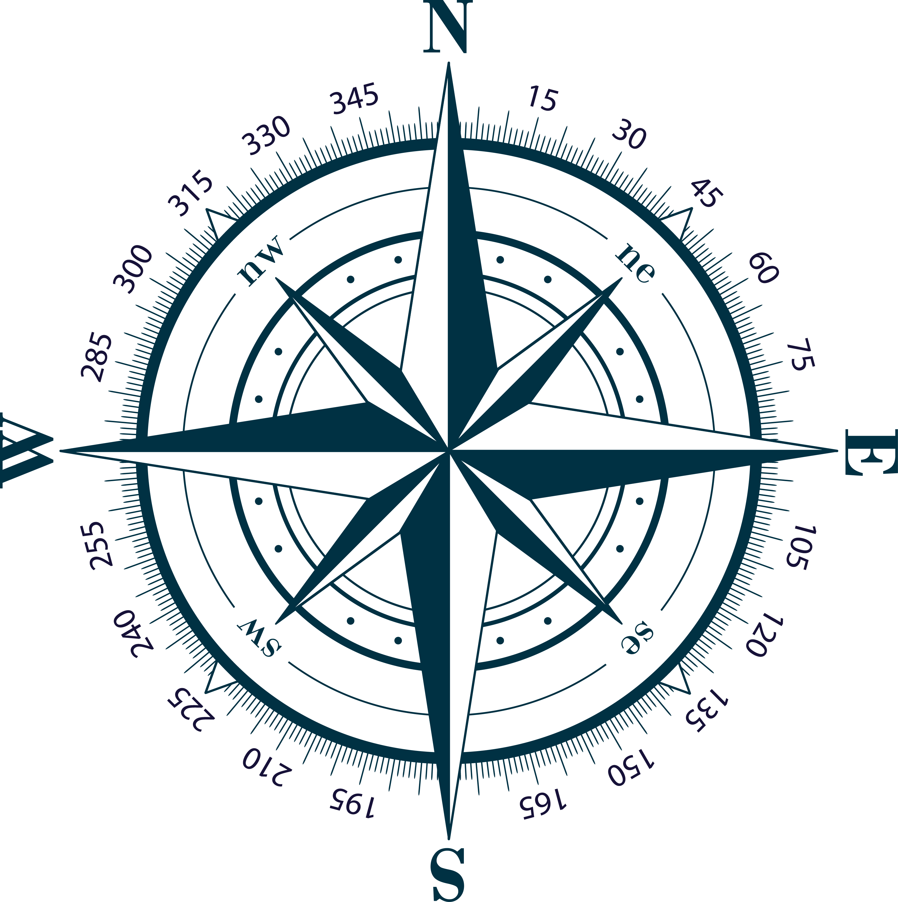

Clockwise the degrees (°) increase and anti-clockwise the degrees decrease.
Example 1:
Say the current heading is 0° and the required heading is 30°.
Curr = 0°
New = 30°
Curr < New (less than) therefore we must turn clockwise, i.e. turn to the right to increase the heading from 0° to 30°.

Small Turn Angle
It is also desirable to keep the turn angle as small as possible.
In the example below to change your heading from 0° to 270° would require a 270° turn to the right. But turning left would only require a 90° turn.
Current = 0 degrees
New = 270 degrees
So, if the difference between New and Curr is greater than 180° then the opposite angle would be smaller. Therefore, a turn to the left would get to the new heading faster.

Optimised Turn Angle Examples
Example 2:
Say the current heading is 340° and the required new heading is 30°.
Curr = 340°
New = 30°
Curr > New (greater than) therefore we must turn anti-clockwise, i.e. turn to the left to decrease the heading from 340° to 30°.
But does this result in the smallest turn angle?
What is the difference between Curr and New?
Curr – New = 340° – 30° = 310° which is greater than 180°.
Which means the opposite angle would be smaller, (360° – 340°) + 30° = 50° instead of 310°.
Therefore, turning right, clockwise would be more efficient.
Example 3:
Say the current heading is 340° and the required new heading is 220°.
Curr = 340°
New = 220°
Curr > New therefore we must turn anti-clockwise, i.e. turn to the left to decrease the current heading from 340° to the desired new heading of 220°.
Check for smallest turn angle:
Curr – New = 340° – 220° = 120° which is less than 180°.
Which means the left turn angle is the smallest and turning left is the best.
Example 4:
Say the current heading is 0° and the required new heading is 220°.
Curr = 0°
New = 220°
Curr < New therefore we must turn clockwise, i.e. turn to the right to increase the current heading from 0° to the desired new heading of 220°.
Check for smallest turn angle
New - Curr = 220° – 0° = 220° which is greater than 180°.
Which means a left turn, anti-clockwise, must be made as the left turn angle is the best.

Code
if curr_heading > target_heading:
if curr_heading - target_heading > 180:
turn_right()
else:
turn_left()
else:
if target_heading - curr_heading > 180:
turn_left()
else:
turn_right()

